OSU Climate Plan DRAFT
8/17/09

Table of Contents
Definitions
Introduction
Infrastructure
GHG Inventories
Baseline
Goals
Financing
Measurement, Tracking & Reporting
Education and Community Engagement
Research

Definitions of Key Terms
(1) “Carbon dioxide” (CO2) means the chemical compound containing one atom of carbon and two atoms of oxygen.

(2) “Carbon dioxide equivalent” (CO2e) represents the quantity of a greenhouse gas multiplied by a Global Warming Potential (GWP) factor, relative to CO2. This is the “standard unit” used to quantify various greenhouse gasses.

(3) “Global Warming Potential factor” (GWP) means the radiative forcing impact of one mass-based unit of a given greenhouse gas relative to an equivalent unit of carbon dioxide over a given period of time. For instance, methane (CH4) has a GWP of 23, meaning that every gram of methane will trap 23 times as much solar radiation as a gram of CO2.

(5) “Greenhouse gas” (GHG) is any gas that contributes to anthropogenic global warming including, but not limited to, carbon dioxide, methane, nitrous oxide, hydrofluorocarbons, perfluorocarbons, and sulfur hexafluoride.

(6) “Metric ton, tonne, or metric tonne” (mt) means one metric tonne (1000 kilograms) or 2204.62 pounds.

(7) “Total emissions” or “Gross emissions” is the calculated sum of GHGs emitted due to OSU-related activities.

(8) “Net emissions” is the calculated sum of GHGs emitted minus renewable energy certificates, composting activities and carbon offsets.

(9) “Renewable energy source” means any source of energy that is replenished rapidly by natural processes. Renewable sources may include, but are not limited to, wind, solar, hydroelectric, biomass, geothermal, tidal or sea currents etc.

(11) “Renewable Energy Credit” (REC) is a tradable certificate that represents a unit of energy produced by renewable energy sources. The owner of a REC can claim that they are using renewable energy equal to the amount of RECs owned.

(13) “Renewable energy fee” or “Green fee” refers to the student-approved initiative that directs $8.50 per term per student towards the purchase of RECs. These RECs offset a large percent of OSU’s electrical consumption with additions of clean, renewable energy to the electrical grid.

(14) “World Business Council for Sustainable Development (WBCSD)” is a global association of business representatives that deals exclusively with business and sustainable development.

(16) “Intergovernmental Panel on Climate Change (IPCC)” is a scientific body established to provide policymakers with an objective source of information on climate change. The IPCC performs no research nor does it monitor climate data; it instead offers analysis of research and climate data as an objective body with a broad range of views, expertise and wide geographical coverage.

(18) “American College and University Presidents Climate Commitment” (ACUPCC) is an effort to encourage commitments from institutions of higher learning to neutralize greenhouse gas emissions and prioritize the research and education efforts aimed at stabilizing earth’s climate.

OSU CLIMATE PLAN DRAFT

Introduction

As one of only two institutions in the United States with land, sea, space and sun grant designations, as well as being ranked by the Carnegie Foundation as having “very high research activity”, Oregon State University (OSU) has significant potential to make major contributions to human understanding of and adaptation to global climate change, while demonstrating real ways to reduce human impact on the Earth’s climate.

OSU is emerging as a recognized national leader in sustainability. Key accomplishments include:
- Being recognized by organizations like the US Environmental Protection Agency and the Sustainable Endowments Institute as a leader in campus sustainability, ranking in the top 25 colleges and universities in the nation.
- The journal Conservation Biology ranked OSU’s conservation biology program No. 1 in North America
- OSU ranks 17th among all U.S. universities in R&D expenditures in Environmental Sciences
- Oregon Sea Grant at OSU is the nation's top-ranked Sea Grant program.
- U.S. News and World Report in 2007 ranked the Oregon Master of Public Health Program (OMPH) in community health second in the nation.
- OSU ranks sixth in the United States and eighth globally in coral reef research cited for its scientific significance.

Oregon State recognizes the potential of organizing these efforts into a comprehensive sustainability strategy. In signing the American College and University Presidents Climate Commitment (ACUPCC), OSU President Ed Ray prompted the university to begin a strategic planning process for climate neutrality. As stated in the ACUPCC, OSU is required to:

Within two years of signing this document, develop an institutional action plan for becoming climate neutral, which will include:

i. A target date for achieving climate neutrality as soon as possible.

ii. Interim targets for goals and actions that will lead to climate neutrality.

iii. Actions to make climate neutrality and sustainability a part of the curriculum and other educational experience for all students.

iv. Actions to expand research or other efforts necessary to achieve climate neutrality.

v. Mechanisms for tracking progress on goals and actions.

As a sustainability leader, OSU would seem well positioned to move easily toward climate neutrality. However, the challenges faced by this institution to truly achieve a climate neutral state are as daunting as for most other large public research institutions.

Recent planning initiatives have articulated OSU’s strategic direction with respect to its education, research and outreach activities. The Oregon State University Strategic Plan charts a path for OSU to become one of the top 10 Land Grant universities in the United States.

Climate Plan Organizational Framework

In the same way the OSU Strategic Plan addresses to the university’s mission on a broad scale, a strategic effort is necessary to articulate an institutional vision to move toward climate neutrality. Indeed, this climate plan highlights and builds on the strong emphasis on sustainability in the Strategic Plan, which outlines the following Signature Areas of Distinction:
- Advancing the Science of Sustainable Earth Ecosystems
- Improving Human Health and Wellness
- Promoting Economic Growth and Social Progress

Building on the OSU Strategic Plan and other planning efforts, this document identifies a strategic framework for achieving climate neutrality at Oregon State University. While strategy is outlined in this plan, not every implementation tactic is specified. Because of the size and complexity of OSU, a separate living document will specify a more comprehensive set of tactics than can be detailed here. Since a full implementation plan will contain potentially hundreds of actions, this document contains a set of example actions associated with each goal and strategy. These example actions are included to give a sharper flavor to the strategic direction outlined in this plan.

This document is supported by a variety of other documents, as outlined in Appendix __. Where appropriate, links to these supporting and reference documents are included in the text of the climate plan, particularly since it is anticipated this will be largely circulated as an electronic document.

OSU’s climate planning work will be supported by other planning, tracking and implementation efforts. For example, when it is available, OSU will use the Sustainability Tracking, Assessment and Rating System (STARS) from the Association for the Advancement of Sustainability in Higher Education (AASHE). AASHE has indicated STARS will be released in 2009.

It is expected that the Climate Plan, its implementation documents, STARS, Oregon University System and State of Oregon goals, combined with existing campus efforts, will round out Oregon State University’s efforts to manage common sustainability and climate change issues. By these methods, OSU expects to remain among the top 25 institutions in the United States addressing sustainability and climate issues.

This Climate Plan is divided into three “chapters” meant to address the specific components of the ACUPCC (items i-v above):
- Infrastructure – focuses on the operational components of the university including, building operation, transportation, and other business practices. This chapter addresses items i, ii and v above.
- Education and Engagement – discusses campus community learning, including curriculum, experiential learning and employee and community engagement. This chapter addresses item iii above.
- Research – outlines institutional research strengths on which future actions can be built. This chapter addresses item iv above.

The three chapters each contain two primary subsections, the purposes of which, respectively, are to:
- Reference Phase II of the OSU Strategic Plan as the official and most up-to-date document articulating university vision and direction, and highlight points from the Strategic Plan that are relevant to the ACUPCC and the Climate Plan.
- Share additional information and campus community input gathered and formulated during the climate planning process. These are included as Supporting Activities, as they are in support of the OSU Strategic Plan.

Many Supporting Activities support and enhance specific Strategic Plan Phase II elements.

College and Department Strategies
While several OSU department and college strategic efforts are addressed in each of the three chapters, there are a number of other cross disciplinary efforts worth noting here.

Specifically, several OSU colleges have identified sustainability and climate issues as core components of their college strategic plans, as summarized in the table below.

College of Agricultural Sciences (2004)
  - The Oregon Agricultural Experiment Station plans and carries out its work in the agricultural, biological, social, and environmental sciences. Its director is also the dean of the College of Agricultural Sciences. Research is targeted to improve Oregon’s economic, social, and environmental well-being and sustainability…
  - As part of its Vision. The Oregon State University College of Agricultural Sciences is a responsive force for: fostering economic growth and sustainability…

College of Business Strategic Plan (February 2007)
  - Strategic Initiative – Entrepreneurship and Innovation. Provide expertise and knowledge in developing sustainable business practices and new products, processes and organizational forms.
  - Desired Capabilities – Education Programs. We offer high quality business education integrating information technology, ethics, sustainability, the global economy, and the entrepreneurial process.
  - Scholarship Objectives and Actions – Measures to assess progress in meeting required capabilities for “Scholarship”. Faculty publication and productivity especially in family business, sustainability, and entrepreneurship and innovation.
  - Infrastructure Objectives and Actions -- Objective: Maintain the physical facilities and implement sustainable practices. Establish baseline to measure sustainable practices in the building and implement and implement best practices.

College of Forestry Strategic Plan (Spring 2002)
  - Three overarching themes that encompass our goals: …Broaden and diversify interests and scope of programs…Become the world leader in interdisciplinary approaches to achieving sustainability of forest resources.
  - Seven major factors that will influence the College’s future. The world and the workplace require professionals who possess and are comfortable with diverse ideas, perspectives, and cultures. The College aims to produce a diverse community of graduates who will enrich society, solve complex problems, and help achieve sustainability.
  - Goals of the College of Forestry – Develop collaborative and interdisciplinary approaches to address complex issues through teaching, research, and extended education. Expand activities of the Sustainable Forestry Partnership.

College of Oceanic and Atmospheric Sciences Strategic Plan (Executive Summary, 2008)
The COAS scientific focus has long been on integrative Earth System Science with emphasis on the impacts of global scale processes on the Pacific Northwest. This focus directly supports the College’s goal to ensure the long-term ecological and economic sustainability of our region through fundamental research, technology development, and the creation of meaningful partnerships within the University, with government agencies at all levels, and with the private sector.

Highlighted “Sustainability” Statements in OSU College Strategic Plans
Source: Institute for Natural Resources

[Are there other documented college or dept. strategic efforts that should be included?]

As mentioned, the OSU Strategic Plan rearticulates and keeps current Oregon State University’s institutional vision and mission. Strategic Plan Phase II responds to the changing needs of students, the research community, the State of Oregon and Earth’s ecosystems.
OSU Strategic Plan - Phase II

In 2008-2009, Oregon State University embarked on an effort to create Phase II of its 2004 Strategic Plan for the 21st Century. This effort included adoption of a single overarching imperative and two educational action commitments to guide the university from 2009-2013. Phase II also refined the 2004 Strategic Plan thematic areas into three new Signature Areas of Distinction:
- Advancing the Science of Sustainable Earth Ecosystems
- Improving Human Health and Wellness
- Promoting Economic Growth and Social Progress

Strategic Plan Imperative and Action Commitments

The Imperative identified in Phase II of the Strategic Plan is to foster exceptional education research and outreach initiatives that sustain human well being and improve the quality of human life. Acting on this imperative requires understanding diverse, complex interactions among populations, demographics, human health, climate, access to natural resources (including safe food, clean water and air, and wood products), sustainability, economic vitality, cultural diversity, and new technologies, among others. Well-being and quality of life are enhanced by the fine and performing arts and the humanities and social sciences, which promote understanding and improvement in human interactions within and across cultures.

Phase II includes two commitments, paraphrased here:
- OSU will lead in developing a globally competitive workforce and an informed and capable citizenry. Students will acquire the understanding of major political, social and intellectual trends – and the functions of the natural world – necessary to address complex academic and research problems.
- OSU will address multifaceted national and global challenges that resist simple technical or social solutions.

Strategic Plan Signature Areas of Distinction

While all three areas of distinction have traceable connections to principles within the sustainability movement, and ties to human understanding of and influence on climate change, the Signature Area of Advancing the Science of Sustainable Earth Ecosystems outlines a strategic direction that most directly meets the tenets of the ACUPCC.

The Ecosystems Signature Area goes on to be defined as OSU’s opportunity to create superior learning opportunities for students by:
Improving the understanding of the earth ecosystems upon which all life depends, and promoting their sustainability through high-impact public policy involvement with issues such as climate change, food security and safety, renewable energy production, and economically viable natural resource management

The creation of the Ecosystems Signature Area developed out of OSU’s understanding of historical environmental problems associated with the era since the Industrial Revolution. Complications generated by population growth, economic activity and consumption of fossil fuels, have prompted OSU leadership to identify consequences for oceans, forests, agricultural lands, fresh water and the atmosphere.

This signature area also identifies future challenges at both the local and global scales:
- linking the drivers of climate and ecosystem change to their impacts on natural and human systems
- assessing strategies to mitigate the human “footprint,” (such as carbon sequestration, consumption moderation, and resource conservation)
- formulating strategies that balance sustainable environmental, energy [social?], and economic systems

OSU has several top-ranked programs that give it tremendous advantages in the study of earth ecosystems. Also, synergy is attained by close proximity and interdisciplinary interaction of faculty and students from these programs. Capabilities in these areas represent an opportunity to establish distinctive interdisciplinary educational programs that teach students how to solve problems creatively at the overlap of natural and human systems.

Strategic Plan Goals

Phase II of the Strategic Plan reaffirms three goals:
- Provide outstanding academic programs that further strengthen performance and pre-eminence in the three Signature Areas of Distinction.
- Provide an excellent teaching and learning environment and achieve student access, persistence and success through graduation and beyond that matches the best land grant universities in the country.
- Substantially increase revenues from private fundraising, partnerships, research grants, and technology transfers while strengthening our ability to more effectively invest and allocate resources to achieve success.
Infrastructure
Introduction:
As stated in the Education for Climate Neutrality and Sustainability: Academic Guidance for ACUPCC Institutions, signatory institutions to the American College and University Presidents Climate Commitment (ACUPCC) must detail:
- Campus Emissions – describes the institution's current emissions trajectory and sets a target date for climate neutrality. This section should include visual representations of the institution's emissions trajectory under business as usual and under the ACUPCC plan, as well as a graph illustrating the contribution to the institution's total emissions from each emission source.

- Mitigation Strategies – shows how the institution intends to achieve climate neutrality. This section should include sub-sections describing how the institution will neutralize emissions from each source.

Climate neutrality is defined by the ACUPCC as “…having no net greenhouse gas (GHG) emissions, within a minimum scope of boundaries” described by the Commitment.

It is also noted that climate neutrality should be achieved by “…minimizing GHG emissions as much as possible, and using carbon offsets and other measures to mitigate remaining emissions.”

This Infrastructure section contains five primary subsections, the purposes of which are to:
- Explain the imperative for a Climate Action Plan, including references to the Phase II of the OSU Strategic Plan, the Facilities Services’ Strategic plan, and other risk management reasons;
- Detail current campus emissions, state and institutional goals, and depict trajectories;
- Detail current and future actions, policies and procedures related to infrastructure; reduction goals for each emissions source and the mitigation scenarios and strategies that will enable OSU to meet either state or internal goals; and a financial analysis of scenarios;
- Described tracking, measurement and reporting protocols;
- Make general recommendations on a course of action.

- Imperative For Action
1.1 OSU and Facilities Services’ Strategic Plans
In supporting OSU’s mission-related activities of education, research and outreach, it is extremely important to model the tenets of the mission in the operation and management of infrastructure. Because the operation of this infrastructure is responsible for the real emissions of greenhouse gases (GHGs), infrastructure is a central focus of the ACUPCC and this climate plan.

While the OSU Strategic Plan’s main focus is on the mission-related activities of OSU, infrastructure is also recognized as a critical component in supporting the mission. Additionally, for many disciplines, opportunities for experiential learning exist on campus in relation to infrastructure. Such an opportunity has been and can be further captured in the creation and implementation of this Climate Plan.

Strategic Plan Phase II also includes “Substantially reducing OSU’s carbon footprint” as a university-wide initiative. As such, this Climate Plan is the first of many steps to implement that portion of the Strategic Plan Phase II.

Facilities Services, the department responsible for the development and maintenance of campus infrastructure, has a Strategic Plan that recognizes the need for a “reliable utility infrastructure” and “well-maintained buildings that support our staff”. Connecting these values with a reduction in greenhouse gas emissions may be somewhat abstract, but a large portion of the climate plan will focus on buildings and making them more efficient. Efficient buildings are typically healthier and more reliable, highlighting additional benefits of efficient buildings.

Financial considerations cannot be ignored. Efficient buildings cost less to operate than their less-efficient proxies. By using resources efficiently, emissions of GHGs are reduced and financial savings are realized as well. The economic benefit of building efficiency cannot be overlooked, and many emissions reductions actions will yield some cost savings.
1.2 Other Reasons to Act
Beyond what is stated in the strategic plans above, there are numerous reasons why OSU should act to reduce its emissions.
- Reduce energy expenditures and buffer the effects of volatility in the energy markets
  - Many of the strategies presented below have associated cost-savings, which will reduce OSU’s energy expenditures, improving long-term financial health. Reduced consumption of energy will reduce OSU’s risk in often-volatile energy markets.
- Reduce the exposure of the university to future regulation
  - Legislation is currently being proposed that could cap or tax carbon emissions. By acting now, OSU minimizes its exposure to the effects of this legislation. It is predicted that reducing emissions, either through infrastructure improvements or offsets, will only become more expensive as time passes.
- Increase research and educational opportunities
  - The design, construction and implementation of new technologies and practices that reduce emissions will require significant investments in research and education. Institutions could achieve win-win-win scenarios, by attracting R&D dollars, offering experiential learning opportunities and reducing emissions.
- Appeal to the desire of students, faculty and staff, and the community
  - There has been significant interest in OSU’s environmental impacts from stakeholders. 70% of voting students voted ‘Yes’ to install the $8.50 per term ‘Green Fee’ which purchases renewable energy credits (RECs).
- Be a leader in an area where OSU holds significant scientific clout
  - OSU is nationally recognized for its research related to Geosciences, Atmospheric Sciences, Agricultural Sciences, Forestry and Conservation Biology. These fields are all closely related to climate, and inaction by the institution on emissions may damage OSU’s scientific reputation.

- Current Emissions, Reduction Goals and Emissions Trajectories
2.1 FY08 OSU Emissions
In Fiscal Year 2008, OSU had total gross emissions of 170,197 metric tonnes (t) of carbon dioxide-equivalent (CO2e), a unit commonly used for reporting emissions of greenhouse gases. This represents a 2.3% increase from FY07. Net emissions were 117,210 t CO2e, a 29.6% decrease from FY07. The majority of this decrease was due to the student-funded purchase of renewable energy credits (RECs). Emissions by source are displayed in Table 1. In Figure 1, emissions from FY90 to FY10 are shown graphically by source.

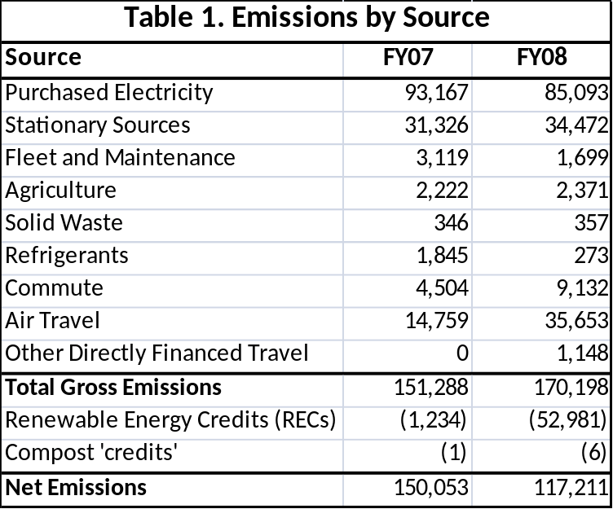

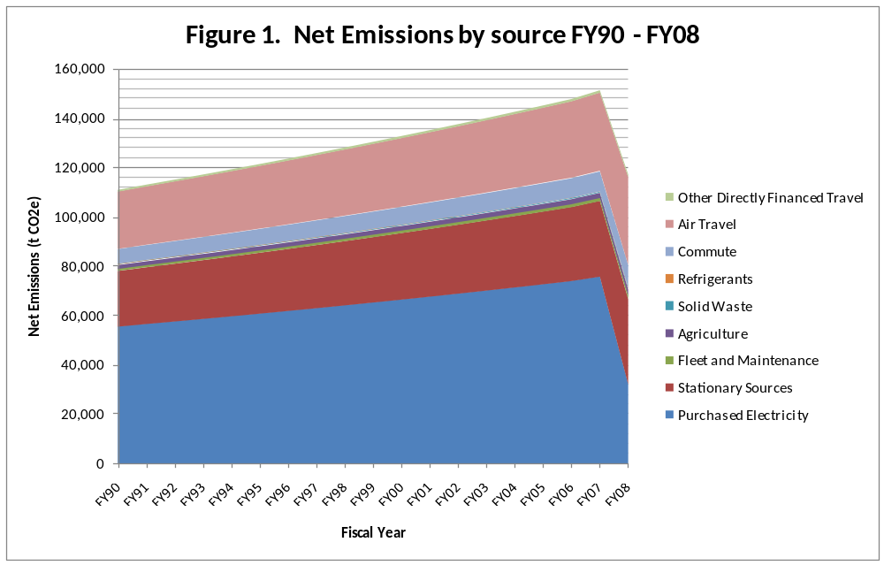

It should be noted that the emissions reported above are not comprehensive; potentially large emissions sources like embodied energy of purchased goods, emissions from construction, and long-distance student travel (for study abroad, travel to/from home and university, etc.) are not included. However, the emissions reported above meet and exceed the reporting requirements of the ACUPCC. OSU will continue to use the existing scope included above for reasons detailed in the FY08 Greenhouse Gas Inventory Report.

2.2 State and Institutional Goals
Governor Kulongoski enacted with Executive Order 06-02, and the Legislature ratified with HB3543, the following state greenhouse gas emissions goals:

- By 2010, arrest the growth of greenhouse gas emissions and begin to reduce greenhouse gas emissions.
- By 2020, achieve greenhouse gas levels that are 10 percent below 1990 levels.
- By 2050, achieve greenhouse gas levels that are at least 75 percent below 1990 levels.

It is the desire of this institution to 1) set aggressive and attainable goals to significantly reduce greenhouse gas emissions and 2) achieve climate neutrality. The state goals outlined above do not fully accomplish these desires. Therefore, the following greenhouse gas emissions goals have been set internally by OSU:

- By 2010, arrest the growth of greenhouse gas emissions and begin to reduce emissions.
- By 2012, achieve net greenhouse gas emissions at least 10 percent below 1990 levels.
- By 2020, achieve net greenhouse gas emissions at least 75 percent below 1990 levels.
- By 2025, achieve net climate neutrality.
2.3 Emissions Trajectory
Due to the low availability data needed to create an historical accurate greenhouse gas profile, it is difficult to measure historical emissions prior to 2003. Using a compilation of recent and sporadic historical data, a rough estimate of FY90 emissions and annual growth of emissions were possible. The analysis estimated:
- FY90 emissions of approximately 111,000 t CO2e
- Annual gross emissions increases of approximately 1.9%
Annual growth of emissions would continue at this rate in a business-as-usual scenario. A major capital project, the Energy Center, will make an immediate and long-lasting impact on emissions. This co-gen facility will burn fuel (mainly natural gas, but also diesel and potentially biofuels) and create not only steam, but electricity as well. It has been estimated that emissions resulting from electricity will decrease by nearly 50%; natural gas consumption will rise by 16%. Due to these factors, emissions for FY10 (the first complete year the Energy Center will be fully operational) should decrease significantly.

Past, current and projected emissions are represented in Figure 2.

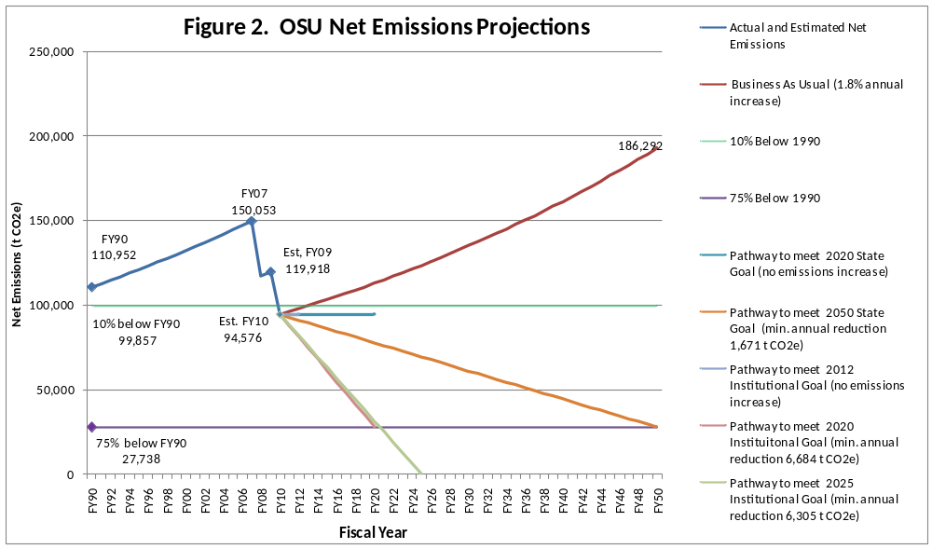
Using the estimated FY90 as a baseline, state goals require FY20 emissions to be no more than 99,857 t CO2e. If the aggressive, internally-set goals are adopted, this level of emissions must be reached by 2012. Even though FY10 emissions are estimated to be less than this level, emissions should not increase or OSU would be noncompliant with State and internal goals because the first interim goal requires arresting the growth of emissions. To achieve state mandate of 75% below 1990 levels by 2050, emissions for FY50 must be no more than 27,738 t CO2e. This would be the required level for FY20 if internal goals are adopted. Climate neutrality, defined by the ACUPCC as having no net greenhouse gas emissions, would be reached by FY25 under internal goals; state goals do not require this target.

- Emissions Reduction Goals and Mitigation Strategies
The sections below include a full set of strategies and example actions to reach climate reduction goals. An implementation document will be developed following submission of this climate action plan, where a comprehensive set of actions will be outlined. A significant portion of building emissions reductions measures will be identified in an energy assessment currently being performed by McKinstry Inc. This assessment is funded by the Oregon University System (OUS) Chancellor’s Office and final results are expected sometime in August.
OUS has defined four mitigation scenarios to help guide the System in its process of supporting campus action toward climate neutrality. Actions outlined in the OSU implementation document will fall into one of the four scenarios:
- Baseline: (business-as-usual) involves “no special effort to save energy or reduce emissions”.
- No-Brainers: (‘low-hanging fruit’) includes “low cost-efficiency measures.”
- No-Regrets: (aggressive energy efficiency and co-generation) includes “aggressive but cost-effective energy efficiency and co-generation measures, requiring significant capital investment.”
- No-Prisoners: (carbon-neutral) is “more aggressive and reduces carbon emissions to zero” and involves no purchasing of carbon offsets
To achieve emissions reduction goals, a blend of actions from the above scenarios will be necessary.
Unrelated to the scenarios outlined above, Figure 3 represents industry approximations for emissions reductions by reduction type: 1) Direct Reduction in emissions (conservation & efficiency), 2) Renewable Energy and Fuels, and 3) Offsets/Sequestration.
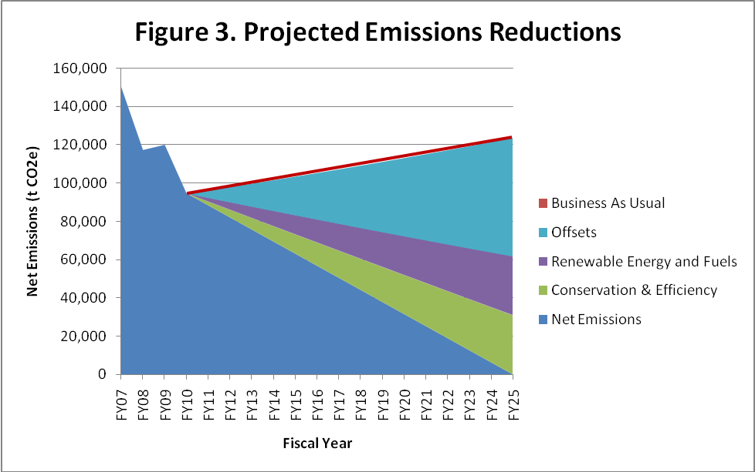
  - Current, Future and Recommended OSU Policies and Procedures Related to Infrastructure
Focused actions and projects are the best way to reduce emissions. A brief list of sample current actions is included below in each of the respective emissions categories. A complete list of current and proposed actions will be detailed explicitly during climate plan implementation.
While these focused actions and projects are integral if we hope to reduce our climate impact, a number of high-level documents and policies also have significant impact.
Current Policies
Facilities Services’ Construction Standards
For any type of construction performed at OSU, there is a detailed set of instructions found in the Construction Standards, which governs the type of equipment to be installed, how it is installed, and how it is maintained. By continually revising the Construction Standards and keeping energy and resource efficiency as primary tenets of the Standards, construction projects should effectively work toward reducing climate impacts.

State of Oregon Policy 125-6-010: LEED-equivalent standards for state buildings
All new construction or renovation of state buildings must meet the State of Oregon version of US Green Building Council’s LEED Silver standard. This policy reduces costs of getting true LEED certification, but forces building designers to seriously consider the impacts that buildings have in relation to energy and resources.

Future Policies
OSU Energy Efficiency and Resource Conservation Policy
Currently undergoing extensive revisions, this policy will act as a guide and reference to students, staff, and faculty . It details priorities and responsibilities of the institution and the occupant in regards to lighting, building temperature set-points, computer power management settings, transportation and other areas. Once approved, the effects should be widespread and lasting.

3.2 Mitigation Scenarios and Associated costs
Costs, both capital and lifetime, will fluctuate significantly from project to project within the different mitigation scenarios. Until all potential actions are analyzed, exact costs to the university will not be known. One thing is almost certain: the longer organizations wait to act, the more expensive emissions reductions and climate neutrality will become.
Estimated costs for the various scenarios are given below:
Baseline (business-as-usual): No increased capital costs; increasing operating expenses

By making ‘no special effort to save energy or reduce emissions’, no additional capital costs will be incurred. However, overall costs to the university will likely be higher over time, as both energy consumption and related costs will increase.

No-Brainers (‘low-hanging fruit’): Annual capital costs of up to $250,000; decreased operating expenses is expected to largely negate capital costs over the short term (1-5 year payback).

While the cost threshold for ‘low cost-efficiency measures’ is not defined by OUS, it is reasonable to assume that the capital cost would be sufficient to make an impact yet not large enough to significantly alter the university’s spending priorities. With this reasoning, it is estimated that this threshold would fall somewhere between $100,000 and $250,000.

With the mention of ‘low-hanging fruit’, it is assumed that these measures would focus on not only low cost measures, but also efficiency measures with short payback times. If low-cost, short payback projects are the initial focus, the University could see no net cost or even a small positive balance as cost-savings continue. This positive cash flow could be used to fund future high capital cost projects.

No-Regrets (aggressive energy efficiency and co-generation): Annual capital costs of up to $3 million for _xx years; funding mechanisms could marginalize capital costs; estimated net savings of up to $5 million over a 15 year period

With emphasis on ‘aggressive but cost-effective energy efficiency and co-generation measures’, this scenario is likely to result in ‘significant capital investment’. These investments could be implemented so that savings from energy efficiency and conservation measures ‘seed’ or fund projects in the future. While there would be large initial capital costs, the added costs to the university could be marginalized by using this energy-savings fund.

Figure 4 is an example of an analysis done by the University of California – Santa Barbara estimating annual costs, annual savings and cumulative cash flow for a variety of projects that would reduce emissions by over 4,500 t CO2e annually by 2013 and yield a net savings of $5 million.

It is expected that OSU could achieve this level of mitigation and cost-savings.
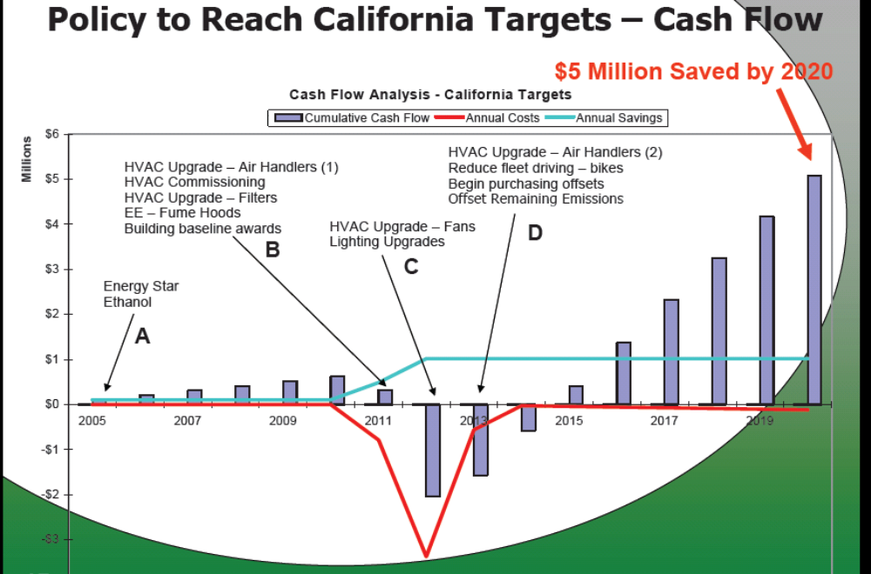
Figure 4. Source:

No-Prisoners (carbon-neutral): Annual costs of $25 million and up for xx years, increased capital construction costs of up to 10%; significantly reduced operating expenses could yield savings in a 25-50 year timeframe

A scenario that “reduces carbon emissions to zero” and “involved no purchasing of carbon offsets” is extremely aggressive, and on the edge of feasibility at this point in time. Reducing carbon emissions to zero without offsets would require massive infusions of capital into renovating existing buildings, and many other measures. New construction would be pushed to a stringent standard and construction costs would increase as a result. However, carbon-neutral buildings will have very low operating costs. Over time, this could yield financial savings to the university, but evidence to support this claim is limited at this time.

Offsets and Renewable Energy Credits (RECs): Annual costs of $2.5 million and up; no change in operating expenses

The estimated market price of carbon offsets ($/ t CO2) and RECs ($/MWh) over the coming xx years varies wildly, with some sources estimating carbon offset prices of $15/t while others estimate prices of over $100/t. Legislation and market forces will drive the actual cost of offsets, and with the uncertainty over future legislation, future carbon prices are equally uncertain.

Currently, OSU pays approximately $5 to offset, through RECs, one metric tonne of CO2e. The current price for a verified carbon offset varies between $2.75 and $33 per t CO2e offset. In the regulated European Union market, carbon offsets are currently valued at €15 or approximately $21/ t CO2e.
Assuming a carbon offset price of $15/t CO2e, it would cost OSU approximately $2.5 million to fully offset current emissions. If emissions, carbon offset prices, or both, increase, this cost will increase. The uncertainty of future legislation and the volatility of the carbon offset market will increase OSU’s exposure to financial risk if an ‘All Offset’ mitigation scenario is selected.

While actual reductions of GHG emissions are desirable, it is likely that carbon offsets will play a role in achieving carbon neutrality for the foreseeable future. There has been considerable controversy relating to carbon offsets, their effect on the environment and disadvantaged populations, as well as their actual impact on reducing GHG emissions. While some of these issues are well-founded, there are independent organizations that have created standards for carbon offsets that ensure offsets are indeed reducing net carbon emissions. OSU shall, in any of its purchases of offsets or renewable energy credits (RECs), ensure that the all purchased offsets are:
- Real and measureable – emissions will be reduced and these reductions will be measureable
- Additional – emissions reductions would not have occurred otherwise
- Permanent – emissions reductions are permanent
- Independently verified – actual emission reductions will be verified by a 3rd party organization such as Green-e or the Voluntary Carbon Standard

3.2.1 Overarching Strategies
The four mitigation scenarios provided by OUS provide a framework in which to think about mitigating carbon emissions. In reality, moving toward climate neutrality at any institution will require a blend of actions within each of the four mitigation scenarios. In general it is expected that the institution will move from implementing highly cost effective (no brainers) measures to lower cost effective (no prisoners) measures over time. There are other considerations besides cost effectively reducing emissions, however, including regulation, student interest, marketing/recruiting advantages, etc. For example, OSU students each year contribute to purchasing renewable energy certificates, which significantly reduce OSU’s net emissions. This action would not necessarily end up as a no brainer type action, but OSU will continue to purchase RECs based on student support for the program.
Similar to overarching strategies of moving from most to least cost effective emissions reduction measures and considering other factors, different financial strategies are available to help execute steps toward climate neutrality.
Financing Strategies
Pay-as-you-go Strategy:
While this strategy would require a one-time infusion of capital, the essence is that each efficiency project would be funded by savings generated from a previous project. A blend of quick pay-back actions, some low cost, others higher cost, would be implemented initially, and the energy savings generated from these projects would renew the account. Only if sufficient funds are available could additional projects begin.
Variation: Depending on the success and rate of return of this strategy, additional capital could be infused at any time. Also, the university could choose to ‘invest’ in this fund, providing capital in return for a dividend or interest payment that would depend on the return on investment.
All Offset Strategy:
This strategy would allow OSU to become climate neutral nearly instantly. OSU would pay for RECs or offsets that would bring net emissions to zero. Upfront costs may be lower than a capital improvement strategy, though reduced operating costs and other ancillary benefits would not be realized. If offsets or RECs are purchased at $5/ t CO2e, it would cost $850,000 annually for OSU to claim climate neutrality.
Local Offset Strategy:
Due to OSU’s significant land holdings, there is potential for the university to generate its own offsets, by reforestation projects, carbon sequestration in agricultural land, etc. OSU could also fund projects locally and claim the resulting offsets. Further research into the generation of carbon offsets will be required.
More financing strategies to be included.
3.2.2 Action Analysis
Upon acceptance of this strategic document, a comprehensive analysis of actions will be needed. Actions should be evaluated for upfront cost, lifetime cost, emissions reduction, associated cost-savings, and ancillary benefits (increased equipment lifetime, better indoor air quality, etc.). Upon completion of the analysis, all actions will be represented on a graph similar to Figure 5.

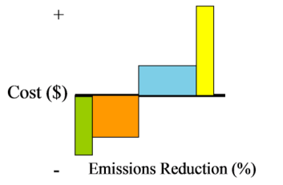Figure 5.

Each vertical bar represents an action. The height of the bar represents cost, while the width of the bar represents emissions reduction. An action with a negative lifetime cost (i.e. a revenue-positive measure) will have a bar that falls below the x-axis. Actions that have a lifetime cost will be above the x-axis. A wide bar represents an action with more emissions reduction potential than a thin bar.

3.3.1 Air Travel
REDUCTION GOAL: By 2012, reduce net emissions from air travel to no more than 40,000 t CO2e
2020 and 2025 figures for each emissions source will be added.

Goal Overview:
In FY08, air travel was the largest source of net emissions for OSU, contributing more than 35,000 t CO2e. Emissions from air travel have increased rapidly in the past years; the European Environmental Agency estimated that emissions from air travel increased 73% between 1990 and 2005. The stratospheric growth of air travel and the lack of alternatives to air travel make this a difficult source to mitigate. Even with these complicating factors, emissions from air travel can be reduced without drastically impacting the way OSU does business. If OSU instead aims to meet state goals (10% below 1990 levels by 2020), no more than 40,000 t CO2e resulting from air travel should be emitted in FY20.

Impact to Stakeholders:
Depending on the strategies and actions chosen to meet the reduction goal for air travel, the effect on the OSU community will vary. Undoubtedly, groups within Business Affairs and our contracted travel agents will be affected. It is likely that Athletics, student groups and others involved in group travel will be affected as well. All faculty, staff and students may be affected in some way if some of the more aggressive strategies and actions are undertaken.

Primary Stakeholders
- Business Affairs
- Contracted travel agents
- Athletics

Summary of Emissions Reduction Strategies:

Strategy 1: Encourage alternative transportation modes
While traveling by plane is certainly the fastest way to go, there are other methods of travel that compare well in terms of speed and convenience but with a much lower carbon impact. In one case, carbon emissions from train travel have been estimated to be 90% lower than a flight of the same distance.
Example Actions: Incentivizing train or carpooling; increasing visibility and use of OSU ride-share site; reimburse carpooling

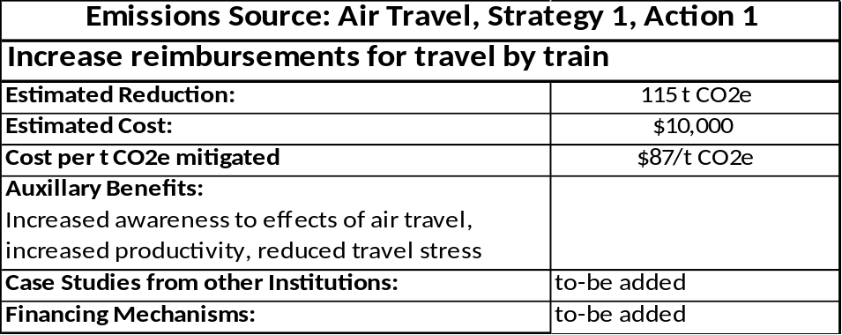
*Note: This is an example of an action that will be included in the full action list in the implementation plan.

Strategy 2: Restrict air travel (or reimbursements) in certain cases
In some cases a restriction on travel (or on personal reimbursements) may be necessary to reduce emissions from air travel to our reduction goal levels. While this could be contentious, information about productivity, actual time commitments of flying, and carbon intensity could alleviate some potential roadblocks.
Example Actions: Eliminate or reduce reimbursements for flights less than 150 miles from point of origin; no athletic or student group air travel for trips less than 250 miles from point of origin

Strategy 3: Encourage use of alternatives to travel (technologies like teleconferencing etc.)
While there are many cases where in-person attendance is required, there are many technologies available that allow us to shrink our world. These technologies could reduce travel time while still providing the desired level of interaction.
Example Actions: Provide teleconferencing technology to entire campus community

Strategy 4: Minimize climate impact of air travel
In the cases where there is no alternative to air travel, we should strive to reduce the impacts of those flights wherever possible.
Example Actions: Encourage purchases from airlines with lowest emissions per mile

Strategy 5: Offset remaining emissions from air travel
There will still be emissions resulting from air travel for the foreseeable future even if unnecessary air travel is eliminated and climate impact of air travel is reduced. In this case, carbon offsets will be necessary to reduce emissions from this source to our reduction goal level.
Example Actions: Include cost of carbon offset in price of all tickets

3.3.2 Stationary Sources
REDUCTION GOAL: By 2012, reduce net emissions from stationary sources to no more than 45,000 t CO2e

Goal Overview:
In FY08, emissions from stationary sources was the 2nd largest source of net emissions for OSU, contributing nearly 35,000 t CO2e. Fossil fuel use for stationary sources has grown by 12% since 1998, the oldest year with intact data. The vast majority (over 95%) of emissions in this category are a result of the combustion of natural gas to make steam for the central heat plant. Due to the Energy Center, a cogeneration facility that will become operational in early 2010, natural gas consumption is expected to increase by more than 15%. If OSU instead aims to meet state goals (10% below 1990 levels by 2020), no more than 45,000 t CO2e resulting from stationary sources should be emitted in FY20.

Impact to Stakeholders:
Nearly all members of the OSU community depend on these stationary sources to heat (or in some cases, cool) their buildings, labs or classrooms. It is desirable that these end-users would not notice any change resulting from carbon mitigation measures relating to the central heat plant or other stationary sources. Facilities Services personnel, including heat plant staff, energy management technicians, steamfitters and others, would likely be most affected by changes to the current system. Their buy-in and expertise would be invaluable for any lasting and significant mitigation measures to occur. NW Natural, Amerigas, Carson Oil and other vendors of fossil fuels may be affected as well.

Summary of Emissions Reduction Strategies

Strategy 1: Increase efficiency of the generation systems that derives energy from fossil fuels
Increasing the efficiency of the current steam generation system is a cost-effective way of mitigating carbon emissions. Associated cost-savings could be significant.
Example Actions: Boiler retrocommissioning project; strengthen preventative maintenance program for boilers and turbines

Strategy 2: Increase efficiency of distribution system that delivers energy from fossil fuels
Once steam has been generated, it must also be distributed across campus. This complicated system consists of numerous pumps, heat exchangers, radiators, valves, tanks, and more. Increasing the efficiency of the distribution system will reduce emissions economically and reduce energy expenditures.
Example Actions: Insulate steam and hot water piping; repair and maintain condensate system
Strategy 3: Decrease user-end consumption (conservation)
Decreasing user-end consumption is a low-cost method of reducing carbon emissions resulting from the combustion of fossil fuels.
Example Actions: Adjust building heating and cooling setpoints; adjust equipment timing; educate building occupants on best practices and efficient products

Strategy 4: Minimize climate impact of stationary sources through use of technologies and alternative fuels
Once efficiency measures are in place and overall consumption has been reduced, emissions from stationary sources will still be considerable assuming fossil fuels are still the primary source of energy. By utilizing alternative fuels and technologies, emissions from stationary sources could be reduced significantly further.
Example Actions: Increased use of biofuels; Implement geothermal heat pumps or solar hot water systems

Strategy 5: Offset remaining emissions from stationary sources
While it is possible to completely eliminate emissions resulting from the combustion of fossil fuels at stationary sources, this may not be the most cost-effective option. Offsets will likely be a part of any carbon reduction plan, and may be the best option once other mitigation strategies have reached the point of marginal returns. However, offsets have little to no educational, cost-saving or behavioral change benefit.
Example Actions: Purchase RECs to offset electricity generated from natural gas at Energy Center

3.3.3 Electricity
REDUCTION GOAL: By 2012, reduce net emissions from electricity to no more than 500 t CO2e

Goal Overview:
In FY08, gross emissions from electricity generation and distribution was the largest source of emissions for OSU, contributing over 85,000 t CO2e. However, due to the large purchase of renewable energy credits (RECs) funded by student-endorsed ‘Green fee’, net emissions for electricity just over 32,000 t CO2e. Electricity use has grown by 19% since 1998, the oldest year with intact data. Emissions from electricity are expected to decrease by 50% over the coming years as a result of the Energy Center. If OSU instead aims to meet state goals (10% below 1990 levels by 2020), no more than 500 t CO2e resulting from electricity should be emitted in FY20.

Impact to Stakeholders: To-be added

Summary of Emissions Reduction Strategies

Strategy 1: Increase efficiency of electrical system
Efficiency and conservation projects are arguably the most cost-effective way to reduce emissions. Not only are total emissions reduced, but each kilowatt saved is one we do not need to purchase or generate. Efficiency projects provide more light, heating, cooling or ventilation per unit of energy.
Example Actions: Lighting retrofits; install variable-frequency drives (VFDs); retrocommissioning building systems

Strategy 2: Decrease user electricity consumption (conservation)
Working hand-in-hand with efficiency upgrades would be projects or policies that decrease electricity use. Conservation projects are relatively low-cost and impart long-lasting educational and behavioral benefits.
Example Actions: Install occupancy sensors; require stringent computer and printer power management; conduct energy campaign/competition

Strategy 3: Minimize climate impact of electricity generation and distribution
Even with all electrical systems functioning at top efficiency and no unnecessary electricity being used, emissions from electricity would still exist in our current system. Example Actions: Install photovoltaic (PV) panels; require that our utility use more low-carbon sources in its power mix

Strategy 4: Offset remaining emissions from purchased electricity
Until all electricity is generated from zero-carbon sources, there will be emissions resulting from electricity generation. RECs or other forms of offsets will likely be a major part of any carbon neutrality strategy.
Example Actions: Increase student purchase of RECs to offset emissions from purchased electricity

3.3.4 Ground Transportation
REDUCTION GOAL: By 2012, reduce emissions from ground transportation to no more than 11,500 t CO2e
Goal Overview:
In FY08, emissions from ground transportation contributed almost 12,000 t CO2e. Emissions from student and employee commute, fleet, athletic bus travel, rental car mileage, and personal vehicle mileage used for business purposes are included in this category. Emissions from this category have increased by 13% since 2004, the oldest year with intact data. Some of this increase represents actual growth, while some is a result of improved data collection. Additionally, there are known sources that have not been captured in past inventories, athletics travel reimbursement for example, so actual emissions from this category may increase further. If OSU instead aims to meet state goals (10% below 1990 levels by 2020), no more than 11,500 t CO2e resulting from ground transportation should be emitted in FY20.

Impact to Stakeholders: To-be added

Summary of Emissions Reduction Strategies

Strategy 1: Encourage alternative modes of transportation/commute (reduce the number of vehicle miles driven)
For ground transportation, like the other categories, the most cost-effective method of reducing emissions is to stop them from being emitted in the first place.
Example Actions: Increase bicycle parking; strategically site operations staff to reduce van miles; actively promote ridesharing

Strategy 2: Minimize climate impact of ground transportation when driving
There is only so much that can be conserved; at some point, people must drive to fulfill job requirements. Emissions resulting from driving can be reduced for these cases
Example Actions: Incentivize use of electric vehicles for commute; encourage use of biofuels

Strategy 3: Offset remaining emissions from ground transportation
Our current transportation system is heavily reliant upon fossil fuels. While there is some movement towards alternative technologies like fuel cell or electric vehicles, these vehicles currently make up a minute fraction of the fleet. If overall mileage driven is reduced and the climate impact of that driving is minimzed, there will still be a significant emissions portfolio for driving. In this case, it may be necessary to purchase offsets to bring emissions from ground transportation into line with goals described here.
Example Actions: Require purchase of carbon offset to receive travel reimbursement
3.3.5 Agriculture
REDUCTION GOAL: By 2012, reduce emissions from agricultural activities to no more than 2,150 t CO2e
Goal Overview:
In FY08, emissions from agriculture contributed almost 2,400 t CO2e. These emissions mainly resulted from the digestive processes of livestock and the fertilization of crops with synthetic fertilizers. Emissions from this category have increased by 26% since 2004, the oldest year with intact data. Some of this increase represents actual growth, while some is a result of improved data collection. If OSU instead aims to meet state goals (10% below 1990 levels by 2020), no more than 2,150 t CO2e resulting from agriculture should be emitted in FY20.

Impact to Stakeholders:

Summary of Emissions Reduction Strategies

Strategy 1: Minimize climate impact of animal husbandry
Animal husbandry is a multibillion-dollar industry and there is continual need for research, education and training related to it. For this reason, there is little chance that the herds and flocks of OSU will disappear anytime soon. These animals will also continue with their biological processes, regardless of the climate impacts of those processes.
Example Actions: Tune animal diets to reduce methane emitted from livestock; improve manure management practices

Strategy 2: Minimize climate impact of crop cultivation
While the physical growth of crops is assumed to be carbon neutral (or even a carbon sink), the synthetic inputs, mainly fertilizer, do have significant climate impacts. Some argue that the emissions from fertilizer are offset by the increased CO2 uptake by plants, but there is not enough conclusive evidence for all types of crops to make that assumption here.
Example Actions: Encourage us of compost or other low emissions fertilizer; increase efficiency of fertilizer spreading on fields using GPS

Strategy 3: Offset remaining emissions from agriculture
Even with proper diet, manure management and low climate impact fertilizer, it is likely that some emissions related to agriculture will exist for some time. Offsets may be necessary in this category to achieve goals or attain climate neutrality.
Example Actions: Require any department that owns livestock to purchase offsets

3.3.6 Solid Waste
REDUCTION GOAL: By 2012, reduce emissions from solid waste to no more than 300 t CO2e by 2020
Goal Overview:
In FY08, emissions from solid waste contributed more than 350 t CO2e. These emissions resulted from methane released from OSU’s landfilled waste. Though the quality of our historical solid waste data is unknown, the amount of landfilled solid waste appears to have stayed consistent over the years. This can be attributed to the rise in enrollment, coupled with higher recycling rates. Historically, all of OSU’s solid waste has been landfilled at Coffin Butte landfill, where since 1995 methane has been captured and used to generate electricity. This technology drastically reduces OSU’s emissions from solid waste, but reduction of the overall waste stream is necessary as well to meet goals. If OSU instead aims to meet state goals (10% below 1990 levels by 2020), no more than 300 t CO2e resulting from solid waste should be emitted in FY20.

Impact to Stakeholders: To-be added
Summary of Emissions Reduction Strategies

Strategy 1: Decrease size of waste stream (or Encourage alternatives to landfill)
While the management of our waste produces emissions that are relatively low, climate-altering compounds are emitted nonetheless.
Example Actions: Promote recycling through competitions; eliminate trays in dining centers; compost all compostable materials on-site.

Strategy 2: Minimize climate impact of solid waste
With our landfill already generating electricity from methane at the site, options to lessen climate impact of solid waste are few and potentially costly.
Example Actions: Work with waste hauler to improve efficiency of system

Strategy 3: Offset remaining emissions from solid waste
As is the case with many of the other categories, it is likely that there will continue to be emissions from solid waste for the foreseeable future. Offsets may be the most cost-effective option by which to reduce emissions from solid waste to the necessary levels.
Example Actions: Require departments that produce large amounts of waste to purchase carbon offsets
3.3.7 Refrigerants
REDUCTION GOAL: By 2012, reduce emissions from refrigerants to no more than 300 t CO2e by 2020
Goal Overview:
In FY08, emissions from refrigerants contributed more than 250 t CO2e. These emissions resulted from the escape of refrigerants into the atmosphere, mainly from refrigeration equipment. In 2004, emissions from refrigerants were nearly 10x as high as they are today. This reduction may be due in part to governmental regulation of refrigerants, as well as thoughtful action on the part of Facilities Operations. Some of the decrease may be pure coincidence however, as emissions from refrigerants vary wildly between years. If OSU instead aims to meet state goals (10% below 1990 levels by 2020), no more than 300 t CO2e resulting from refrigerants should be emitted in FY20.

Impact to Stakeholders: To-be added

Summary of Emissions Reduction Strategies

Strategy 1: Encourage alternatives to refrigerants
By reducing the amount of climate-impacting refrigerants in use, the chances of leaking and maintenance-related issues are reduced.
Example Actions: Promote use of air, water or geothermally-cooled equipment

Strategy 2: Lessen climate impact of refrigerants
There will be cases where there is no suitable alternative to climate-altering refrigerants; in these cases, the impact of refrigerants must be reduced.
Example Actions: Encourage use of low global warming potential (GWP) refrigerants; ensure preventative maintenance regime is followed on refrigerant-containing equipment

Strategy 3: Offset remaining emissions from refrigerants
Eventually a point will be reached where alternatives to climate-altering refrigerants and reduction of their impacts no longer is cost-effective.
Example Actions: Purchase carbon offsets that are generated as a result of reducing emissions related to refrigerants

4.0 Measures of Progress/Tracking/Reporting
The Climate Commitment requires signatories to include “mechanisms for tracking progress on goals and actions” within their climate action plans.
Each year beginning in October or November 2010, OSU will begin including Climate Plan implementation details in the university’s annual greenhouse gas inventory report. This report will become the overarching report on OSU’s climate-related activities from the previous fiscal year, combining findings of the greenhouse gas inventory, and progress on the Climate Plan toward climate neutrality. Updates to goals, strategies and actions to date will be detailed there, and it will be available online.
To track implementation and results of actions, a spreadsheet will be created to capture estimated costs, savings and emissions reductions. This document will be continually updated.
The ACUPCC encourages signatories to reevaluate their plans at least every other year. Modifications to the plans are allowed, though revised plans must be submitted and the reasons behind changes described.
Education and Engagement

Strategic Connections

OSU has achieved far-reaching recognition for outstanding experiential learning opportunities for students, including the innovative Student Sustainability Initiative, an entirely student led, student organized, and student funded organization; installing unique technologies like exercise equipment that generates electricity fed into OSU buildings; and a myriad of other groups organized around sustainability/environmental issues, such as the Global Environmental Change Organization, a graduate student-led group devoted to climate change issues.

The OSU Extension Service addresses the cultural dimensions of Oregon communities and leadership through statewide Extension programs, and had the first Sustainable Living program in the United States. The existing and widespread network of Extension connections facilitates the rapid dissemination of novel programs and new approaches that will help establish and maintain healthy urban and rural populations.

As stated in the Education for Climate Neutrality and Sustainability: Academic Guidance for ACUPCC Institutions, signatory institutions to the American College and University Presidents Climate Commitment must:
- make climate neutrality and sustainability a part of the curriculum and other educational experience for all students
- develop a means of reviewing progress and expanding reach over time

Reflecting overlap between OSU’s institutional principles and the tenets of the American College and University Presidents’ Climate Commitment, the newly created Phase II of the OSU Strategic Plan forms a strong platform for this section of OSU’s Climate Plan.

Strategic Plan Phase II goals One and Two specifically impact Education and Engagement at OSU:
- Provide outstanding academic programs that further strengthen performance and pre-eminence in the three Signature Areas of Distinction.
- Provide an excellent teaching and learning environment and achieve student access, persistence and success through graduation and beyond that matches the best land grant universities in the country.

As noted above, the Ecosystems Signature Area is OSU’s opportunity to create superior learning opportunities for students by:
Improving the understanding of the earth ecosystems upon which all life depends, and promoting their sustainability through high-impact public policy involvement with issues such as climate change, food security and safety, renewable energy production, and economically viable natural resource management

Supporting Activities for Education and Engagement

This section contains Goals, Strategies and sample Actions that support the direction of the OSU Strategic Plan, but were not part of the same planning process. The elements presented here are based on campus community input relevant to Education and Engagement climate planning.

The process of developing these goals, actions and strategies involved small workgroups of volunteers who ranged from graduate students, to teaching faculty to university administrators. To minimize the amount of time contributors spent in meetings, the bulk of the development work fell to the staff of the OSU Sustainability Office. Refinement of ideas and documents also occurred electronically between and during meetings in a collaborative electronic workspace that was set up to facilitate brainstorming,

Announcements were distributed campus wide prior to a climate planning kickoff meeting which was attended by 14 people. This event built on work that had started in the summer of 2008 with a group of graduate students from the Global Environmental Change Organization (GECO), who reviewed and benchmarked other climate plans to find themes that would apply to OSU.

  - Experiential and Applied Learning

Goal 1: OSU students at all levels have in-depth experiential and applied learning opportunities and are aware of these of opportunities.
Strategy 1: Engage existing student groups in campus operations activities that enhance their understanding of energy conservation, renewable energy, and climate issues.
Action 1: By fall 2009, complete implementation of the student-administered Sustainable Energy Revolving Loan Fund approved by students in spring 2009. This fund, infused with $100,000 per year for 5 years starting in fall 2009, will fund conservation/efficiency and renewable energy projects on the OSU campus. Savings from projects will replenish the fund.
Strategy 2: Increase number of paid internships and student worker positions with campus departments and community organizations
Action 1: By winter 2010, develop collaborative list of campus and community sustainability organizations with internship opportunities. Post list online and with OSU Career Services. Linked with Engagement Goal 2.
Action 2: By spring 2010, strengthen hiring and marketing process for paid positions within the Student Sustainability Initiative
Strategy 3: Promote student involvement in and exposure to OSU sponsored research related to sustainability, environmental issues, climate change, etc.
Strategy 4: Provide students unpaid opportunities to learn about and participate in activities for extra credit, curricular requirements, and community service contribution.

  - The Classroom Experience

Goal 1: Make sustainability and climate change issues part of the classroom experience for all students
Strategy 1: Incorporate elements of climate and/or sustainability into all fields of study.
Action 1: Continue development of a sustainability double degree, or similar degree or minor programs
Action 2: Institute an environmental literacy requirement so that all students who graduate from OSU have some exposure to sustainability concepts
Strategy 3: Make students aware of existing class offerings related to climate
Action 1: In fall 2009, the Sustainability Office will build on the Institute for Natural Resources sustainability inventory and publish current course offerings and work with academic departments to keep the results current over time.
Strategy 4: Encourage and provide resources to faculty to incorporate material on climate change in their curriculum. Linked with Employee Development Goal 2.
Action 1: Pilot integration of Northwest Earth Institute discussion course material into specific OSU courses. Facilitate holding courses outside regular structured class time if necessary.

Goal 2: Students seeking a deeper understanding of climate and sustainability issues gain in-depth exposure to sustainability and climate issues by combining a deep as well as broad understanding of those issues.
Strategy 1: Students and faculty have access to in-depth sustainability and climate related learning and service opportunities around which the classroom experience occurs.
Action 1: By June 2010 academic year, the Sustainability Office will create and maintain a menu of existing service learning opportunities that foster a deeper understanding of sustainability and climate change.
Action 2: Starting in fall 2009, the Sustainability Office will begin working with academic departments to increase the number of service learning opportunities that foster a deeper understanding of sustainability and climate change.
Action 3: In fall 2009, involve at least one undergraduate course section in the creation of the FY09 greenhouse gas inventory report.
Strategy 2: Create case studies of early efforts at the unit level that can be used by other OSU units as models for how to integrate sustainability into curriculum. These case studies can include examples of ways to integrate sustainability into strategic plans, syllabi for sustainability courses, etc.

2.3 Campus and Community Engagement

Goal 1: Students, particularly freshman and transfers, are aware of and utilize campus and community climate- and sustainability-related resources at OSU and in Corvallis. Life skills are enhanced by direct engagement with these resources.
Strategy 1: Utilize student orientation events as outreach opportunities
Action 1: Host information tables at events: START, Beaver Fair, etc.
Action 2: By fall 2010, begin regular tours of campus and community green features and destinations.

Goal 2: Connections between Corvallis/surrounding communities and OSU is strengthened in order to deal with pressing global climate issues.
Strategy 1: Community members are aware of and given reasonable access to university experts and specialists.
Action 1: Expand and keep updated a comprehensive list of university faculty expertise organized by topic area.
Strategy 2: OSU departments and community groups are connected with student organizations in order to facilitate internship, volunteer, and work opportunities. Linked with Experiential and Applied Learning Goal 1.
Strategy 3: OSU offers a variety of climate-related events and speakers at its facilities throughout the state.
Action 1: OSU institutionalizes or systematically maintains and increases the number of publicly-available climate- and sustainability-related lecturers

2.4 Employee Development

Goal 1: A complete and comprehensive inventory of existing employee development opportunities that move OSU toward climate neutrality is up to date and available online.

Goal 2: As it relates to their field(s) of expertise, faculty and staff have adequate training and professional development opportunities around issues of climate and sustainability. Linked with Classroom Experience Goal 1, Strategy 4.
Strategy 1: Create a fund and allocation process for faculty development and training on sustainability principles relevant to faculty’s field of expertise or study, or that supports employees’ volunteer activities.
Action 1: Pilot employee development via Northwest Earth Institute course delivery. Distribute information on courses through offices of Training & Professional Development, Community and Diversity, and departmental trainings and meetings. http://oregonstate.edu/admin/hr/training_dev.html Get trainings onto central training calendar.

Goal 3: Faculty and staff actions in the workplace support OSU’s institutional movement toward climate neutrality
Strategy 1: increase employee awareness of possible workplace sustainability practices, as well as the resources (people, training, tools, etc) available to employees that will help them operates their workplaces in way that reduces climate emissions.
Action 1: starting in 2010, reach out to employees at all large employee-oriented events possible, such as University Day and Training Days.
Action 2: by fall 2009, create a list of employee organizations with which to network on an ongoing basis, like labor unions, Association of Office Professionals, Professional Faculty Leadership Association and others. Establish relationships starting in 2010.
Action 3: Create a “sustainable solutions” type award to recognize faculty and staff for great ideas or contributions (similar to program at U of FL.)
Action 4: Encourage all departments to have their workspace undergo a sustainability audit.
Strategy 3: Partner with other organizations to offer low cost training options.
Action 1: Use Oregon Dept. of Administrative Services electronic training modules for state agency employees.

Tracking Progress

The ACUPCC requires campuses to review progress and expand reach over time. The OSU Strategic Plan provides a solid foundation on which to expand reach of institutional efforts related to climate and sustainability. However, additional steps are needed in order to monitor progress.

As such, a reporting framework is needed to track progress toward the strategic and specific efforts toward climate neutrality. The ACUPCC requires measuring and reporting greenhouse gas emissions every two years. OSU has committed to measuring and reporting emissions every year. In concert with annual reporting of greenhouse gas emissions, the OSU Sustainability Office will expand the greenhouse gas inventory report to include specific progress toward elements of the climate plan. This aligns with past inventory reports which have included information on progress to date of all aspects of the ACUPCC, not just measurement and reporting greenhouse gas emissions.

A detailed set of metrics will continue to be developed, and will appear as part of the Climate Plan implementation. Each strategy-level item in the three climate plan chapters are structured so that success is measureable. Certain metrics, like number of courses relating to sustainability or climate change, and number of sustainability-related events and student groups are tracked but not reported on as of yet. The annual climate plan update and greenhouse gas inventory report will include more robust reporting of both existing and new metrics.

Research

Strategic Connections

Across many climate-related disciplines, OSU research strengths run deep. The Carnegie Foundation ranked OSU in its "very high research activity" tier, making it one of only 96 universities in the United States to earn that rating. In 2007-2008, OSU researchers had another record year in sponsored research in which their programs were awarded $231 million – $25 million more than the previous year. Additionally:

- Oregon State University ranks first in the nation in the frequency that its research in Agricultural Sciences is cited in peer-reviewed articles, according to Science Watch.
- Oregon State ranks sixth in the United States in the number of times its research in Geosciences is cited in peer-reviewed articles.
- OSU ranked No. 9 worldwide in the frequency that its faculty members' published research is cited by other researchers

OSU’s proficiency in climate change and emissions mitigation research stems from the university’s roots in natural resources expertise and its land, sea, space and sun grant basis. The OSU Strategic Plan refocuses OSU on its core strengths and three Signature Areas of Distinction. The first such area, Advancing the Science of Sustainable Earth Ecosystems, particularly speaks to the vision of maintaining and enhancing OSU’s natural resources focus.

As stated in the OSU Strategic Plan Phase II, institutional focus since 2004 has:

…resulted in greater interdisciplinary collaboration, scholarly achievement, and external impact, including the development of new institutes and centers targeted at such critical issues as water resources and climate change.

Since the development of the 2004 Strategic Plan, investments in and attention to OSU’s thematic areas has resulted in the development of new institutes and centers targeted at such critical research issues as water resources and climate change.

A prime example of the increased institutional focus on climate change is the new Oregon Climate Change Research Institute (OCCRI), an Oregon University System institute housed at OSU that is charged with networking researchers, serving as a clearinghouse for climate information and providing climate change information to the public. OCCRI will also support the Oregon Global Warming Commission in developing strategies to prepare for and to mitigate the effects of climate change and provide technical assistance to local governments to assist them in developing climate change policies, practices, and programs.

Strategic Plan Phase II continues to encourage large scale inter-institutional research and development efforts such as OCCRI, and focuses interdisciplinary scholarly activity on the most pressing regional, national and global issues.

Other existing research activities and strengths include:
- Alternative Energy and Energy Systems, including wave energy and biomass
- Co-product development, such as enzymes, pharmaceuticals and natural crop control chemicals, and structural materials that can be obtained from locally available crops and plants
- Solar energy, including new photovoltaic compounds that can absorb more light, as well as oxides that can replace the current mainstays of silicon and cadmium
- Examining the effect of haze and clouds on climate change using satellite data

In June 2009, the Institute for Natural Resources (INR) completed an inventory of sustainability-related activities at OSU: Sustainability at Oregon State University. Based on a review of college and department based research focus areas, INR identified six categories of OSU research where sustainability is emphasized. For a full explanation of the six categories, and a list of examples of research activities, please see the full report, linked above.

During Fiscal Year 2007, projects within OSU’s six sustainability strengths, were overwhelmingly funded by federal agencies, with the exception of rural communities, in which funds primarily came from state agency sources of funding.

Sustainability Research Strengths Funding Amount Alternative Energy and Energy Sources $ 5,242,954 Blue Sustainability $ 54,646,393 Climate $ 20,239,141 Green Sustainability $ 46,275,998 Materials, Practices, and Technologies $ 21,424,186 Rural Communities $ 5,634,617 Total $153,463,289

College of Agricultural Sciences (2004) o The Oregon Agricultural Experiment Station plans and carries out its work in the agricultural, biological, social, and environmental sciences. Its director is also the dean of the College of Agricultural Sciences. Research is targeted to improve Oregon’s economic, social, and environmental well-being and sustainability… o As part of its Vision. The Oregon State University College of Agricultural Sciences is a responsive force for: fostering economic growth and sustainability… College of Business Strategic Plan (February 2007) o Strategic Initiative – Entrepreneurship and Innovation. Provide expertise and knowledge in developing sustainable business practices and new products, processes and organizational forms. o Desired Capabilities – Education Programs. We offer high quality business education integrating information technology, ethics, sustainability, the global economy, and the entrepreneurial process. o Scholarship Objectives and Actions – Measures to assess progress in meeting required capabilities for “Scholarship”. Faculty publication and productivity especially in family business, sustainability, and entrepreneurship and innovation. o Infrastructure Objectives and Actions --Objective: Maintain the physical facilities and implement sustainable practices. Establish baseline to measure sustainable practices in the building and implement and implement best practices. College of Forestry Strategic Plan (Spring 2002) o Three overarching themes that encompass our goals: …Broaden and diversify interests and scope of programs…Become the world leader in interdisciplinary approaches to achieving sustainability of forest resources. o Seven major factors that will influence the College’s future. The world and the workplace require professionals who possess and are comfortable with diverse ideas, perspectives, and cultures. The College aims to produce a diverse community of graduates who will enrich society, solve complex problems, and help achieve sustainability. o Goals of the College of Forestry – Develop collaborative and interdisciplinary approaches to address complex issues through teaching, research, and extended education. Expand activities of the Sustainable Forestry Partnership. College of Oceanic and Atmospheric Sciences Strategic Plan (Executive Summary, 2008) The COAS scientific focus has long been on integrative Earth System Science with emphasis on the impacts of global scale processes on the Pacific Northwest. This focus directly supports the College’s goal to ensure the long-term ecological and economic sustainability of our region through fundamental research, technology development, and the creation of meaningful partnerships within the University, with government agencies at all levels, and with the private sector.

College of Agricultural Sciences (2004) o The Oregon Agricultural Experiment Station plans and carries out its work in the agricultural, biological, social, and environmental sciences. Its director is also the dean of the College of Agricultural Sciences. Research is targeted to improve Oregon’s economic, social, and environmental well-being and sustainability… o As part of its Vision. The Oregon State University College of Agricultural Sciences is a responsive force for: fostering economic growth and sustainability… College of Business Strategic Plan (February 2007) o Strategic Initiative – Entrepreneurship and Innovation. Provide expertise and knowledge in developing sustainable business practices and new products, processes and organizational forms. o Desired Capabilities – Education Programs. We offer high quality business education integrating information technology, ethics, sustainability, the global economy, and the entrepreneurial process. o Scholarship Objectives and Actions – Measures to assess progress in meeting required capabilities for “Scholarship”. Faculty publication and productivity especially in family business, sustainability, and entrepreneurship and innovation. o Infrastructure Objectives and Actions --Objective: Maintain the physical facilities and implement sustainable practices. Establish baseline to measure sustainable practices in the building and implement and implement best practices. College of Forestry Strategic Plan (Spring 2002) o Three overarching themes that encompass our goals: …Broaden and diversify interests and scope of programs…Become the world leader in interdisciplinary approaches to achieving sustainability of forest resources. o Seven major factors that will influence the College’s future. The world and the workplace require professionals who possess and are comfortable with diverse ideas, perspectives, and cultures. The College aims to produce a diverse community of graduates who will enrich society, solve complex problems, and help achieve sustainability. o Goals of the College of Forestry – Develop collaborative and interdisciplinary approaches to address complex issues through teaching, research, and extended education. Expand activities of the Sustainable Forestry Partnership. College of Oceanic and Atmospheric Sciences Strategic Plan (Executive Summary, 2008) The COAS scientific focus has long been on integrative Earth System Science with emphasis on the impacts of global scale processes on the Pacific Northwest. This focus directly supports the College’s goal to ensure the long-term ecological and economic sustainability of our region through fundamental research, technology development, and the creation of meaningful partnerships within the University, with government agencies at all levels, and with the private sector.

Table x: Fiscal Year 2007 Funding for grants and contracts
based on Sustainability Strength
Source: Institute for Natural Resources

For research funded during FY07, almost three-quarters of OSU’s research relates to sustainability. For more details, please see Tables 6 and 7 in the INR report, listing department and college level research focus areas. Thirty-four departmental research focus areas cross two or more the six research strength areas.

In support of the Strategic Plan Phase II goals, several strategic initiatives have been identified. One such initiative is to increase total grants and contracts to expand the impact of research on scholarship and the creative work of faculty, and enhance partnerships with the business and corporate sector, other universities and associations, and non-profit and non-governmental organizations.

Federal Research Funding
Demonstrating and Advancing OSU’s Climate-related Research

Of the $231 million of sponsored research in 2007-2008, nearly $136 million came from federal competitive grants from agencies such as the National Science Foundation, the National Institutes of Health, the Department of Agriculture and the Department of Energy. OSU continues to strengthen collaborative relationships with these and other agencies in an effort to enhance research funding. Because of a high reliance on federal funding, OSU research activities will continue to mirror the ebb and flow of interest in climate issues from federal agencies in these areas.

In addition to allocations from federal agencies, OSU occasionally pursues federal appropriations requests for scholarly research, proposals for training and instruction or technology and equipment. By seeking a variety of federal funding for these types of projects, OSU is committing to a significant level of future research into climate-related issues.

As seen by the research activities categorized above, sustainability and climate related research represents a large portion of overall research at Oregon State. OSU’s natural resources expertise supports its competitiveness with respect to external funding and open solicitations for climate related research. For internally funded research activities, the OSU Research Council advises allocation of funding for scholarly research. The recent increase in climate-related research is largely due to growing requests from faculty for such funding. Because OSU’s research priorities are based on – and expected to advance – the university’s Strategic Plan, it is expected the trend toward more climate and sustainability related research will continue.

Future OSU Research Activities

OSU will continue to capitalize on its broad strengths in technology, engineering, science and business to pursue breakthrough advances in renewable and alternative energy, green building technology, and resource and enterprise sustainability. Several alternative energy companies have recently emerged from OSU, and energetic linkages between business, engineering, and science-dependent colleges are giving rise to new degree programs, strategic partnerships with corporations, and acceleration in the process of bringing discoveries to market. All these activities create advanced learning opportunities for students.

As detailed above in the Climate Plan introduction, several OSU colleges have identified research priorities as they relate to climate and sustainability in addition to the goals outlined in the university Strategic Plan. In particular, OSU’s College of Oceanic and Atmospheric Sciences has a stated goal to

“…ensure the long-term ecological and economic sustainability of our region through fundamental research, technology development, and the creation of meaningful partnerships within the University, with government agencies at all levels, and with the private sector.”

Supporting Activities for Research

Goal 1: Stakeholders (including existing and prospective students, federal and state agencies, Oregon citizens, etc) are aware of and, when appropriate, connected to existing climate change and sustainability-related research and the personnel behind this research.
Strategy 1: Incorporate marketing aspects of sustainability and climate research as part of OSU’s integrated marketing campaign.
Strategy 2: Institutionalize tracking sustainability and climate-related research activities.
Action 1: Improve electronic documentation and communications about existing research activities.
Action 2: Enhance communication amongst internal OSU stakeholders by convening one or more cross-disciplinary groups comprised of college representatives who are knowledgeable of efforts in their units. These groups can acts as the bridge to other interested parties in the private and public sectors as well as with community members.
Action 3: involve where possible undergraduate students in research related sustainability and climate issues.

Goal 2: Oregon citizens are aware of potential impacts of climate change and also aware of ways to mitigate their contributions to climate change.
Strategy 1: strengthen information availability to external audiences about regional climate change impacts

Goal 3: Better enable faculty to do ‘top tier’ climate change research
Strategy 1: Create a faculty incentive program to assist in funding climate related research.

