Unit: UABC Accounting

Process/Procedure Owner: Otila Zuschlag

Date of Last Update: January 27, 2013

Title: Incomplete Document report – FGRIDOC
Purpose: To get a listing of incomplete documents in Appworx using your ONID username.

1. A. Logon to: BANNER
B. Select: APPWORX – Run, Logon with ONID username
C. Click: Green Arrow brings up report names
D. In Search Field: Type in ‘FGRIDOC’ – Click ‘Request’
2. Select these Prompts only:

A. Include All Document Types: Yes
B. Enter your User ID

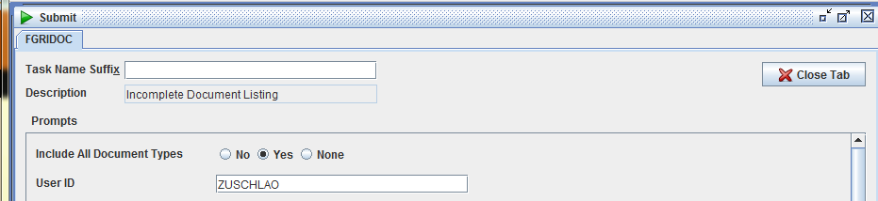

C. Include Vendor Information: Yes
D. Sort Order: check ‘User ID/Document number’

Helpful hint: You can recall this report and run it any time, after the first run.
1. Sign into ‘APPWORX’
- At upper left-corner click on ‘Explorer’ button – Tool Bar screen is displayed
- Click ‘Filter’ and select ‘History Query’
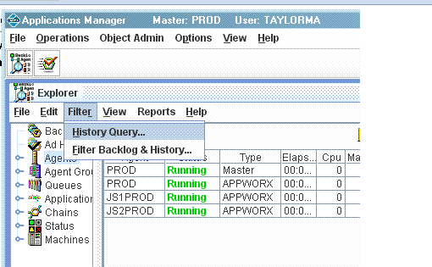
- Enter the job name with the % sign - ‘FGRIDOC%’
- In Requestor box enter your ONID user name: (this will bring up listing of reports previously run under your username).
- Uncheck ‘Current Day’ box
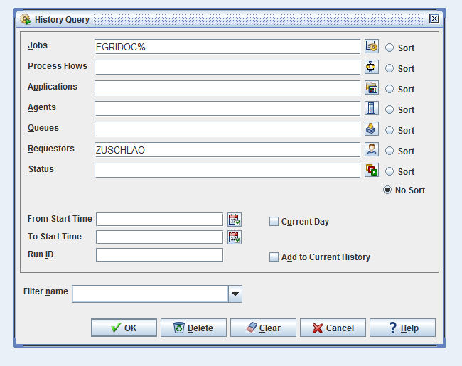

- Click ‘OK’ - History Screen pops up
- Under ‘Task Name’ – Right click on your ‘FGRIDOC’ job and click ‘Request’
(You can revise the ‘Prompts’ if needed).

